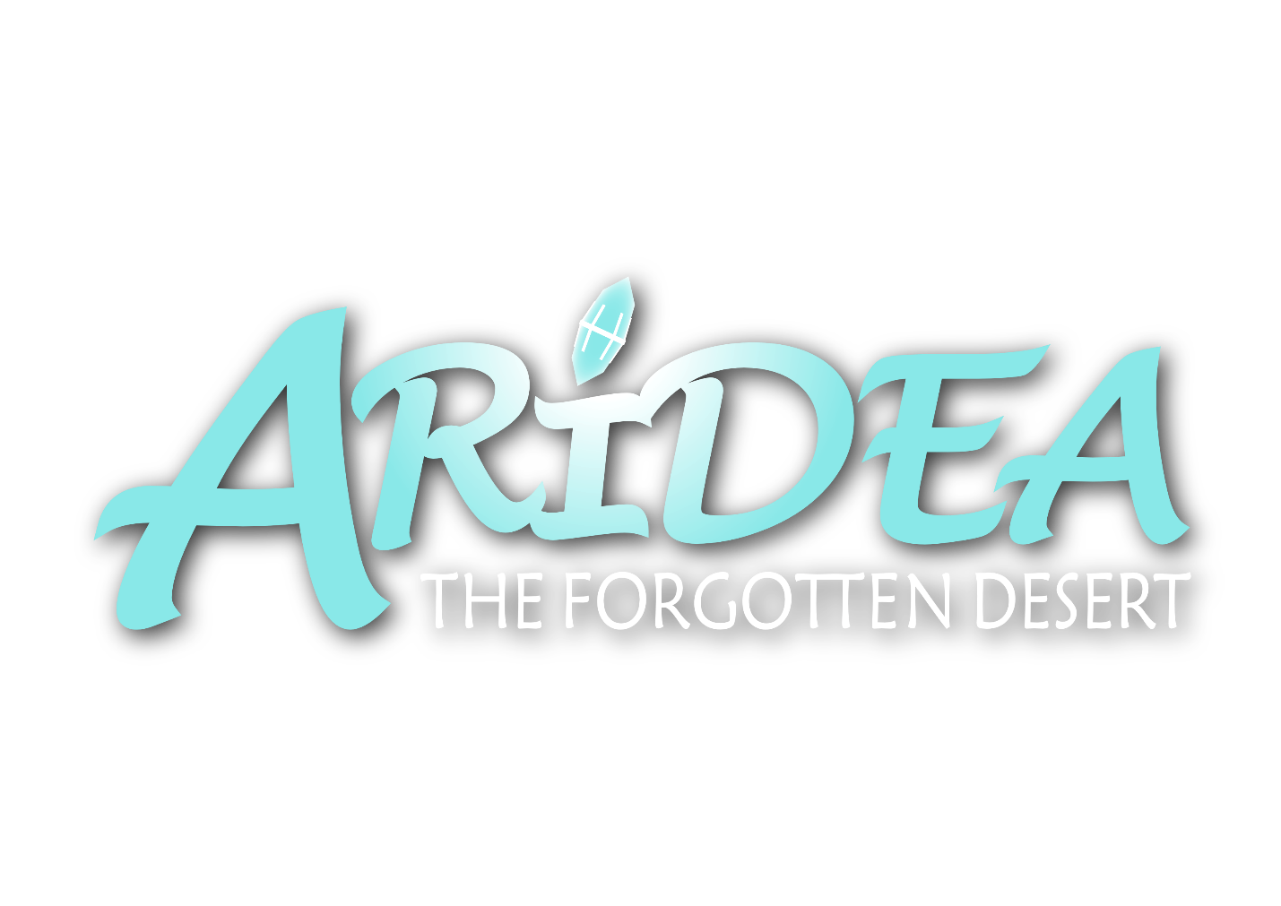

**GAME DESIGN DOCUMENT**



Table of Contents

1.0. Game Overview 4

2.0. Genre 4

3.0. Design Pillars 4

4.0. Gameplay 5

*4.1. Core gameplay* 5

*4.2. Mechanics* 6

4.2.1. Survival parameters 6

4.2.2. Base building 6

4.2.3. Machinery 6

4.2.4. Crystal light 6

4.2.5. Skill trees 7

4.2.6. Inventory 7

4.2.7. Crafting 7

*4.3. Controls* 7

*4.4. Objectives and goals for the player* 8

4.4.1. Long-term goals 8

4.4.2. Short-term goals 8

*4.5. Failure states* 8

*4.6. Game modes* 9

5.0. Story 9

*5.1. Lore* 9

*5.2. Plot summary for the full game* 10

*5.3. Characters* 11

5.3.1. The player 11

5.3.2. Dr. Asher Stone 11

5.3.3. Ghosts 11

6.0. Art and Sound 12

*6.1. Art* 12

*6.2. Sound* 13

7.0. Level Design 13

*7.1. The start* 13

*7.2. The middle: Area 1* 14

*7.3. The middle: Area 2* 14

*7.4. The middle: Area 3* 14

*7.5. The middle: Area 4* 14

*7.6. The end* 14

8.0. User Interface (UI) 15

9.0.Technical Requirement 15

# 1.0. Game Overview

Arídea: The Forgotten Desert is a light-hearted survival adventure game with a darker undertone, where you explore to gather resources and new upgrades before returning to the bases you build to survive the harsh desert, all while trying to open the entrance to an ancient, lost civilization.

The main element used to develop the game’s market identity is the mechanic of ghosts that can only be seen in the light of special crystals. This is a unique feature that can make the gameplay stand out, as well as giving us a solid foundation to build the visual style and identity, which is cute and cartoony with a darker undertone. Another big aspect of the game that will be reflected in its identity is the harsh climate of the desert, more specifically the heat. This is shown through the colors of the game as well as being a major part of the gameplay through survival parameters.

# 2.0. Genre

Arídea: The Forgotten Desert is a survival adventure game. Survival means that everything the player does in the game will either help or hinder them in surviving the desert. Adventure is also an important genre for the game as the player will need to explore the desert to survive it. This will play a part in multiple aspects of the game, such as gathering resources, getting upgrades and exploring the story.

# 3.0. Design Pillars

Dangerous environment. At the core of the game is a survival experience that constantly threatens and challenges the player. This challenge comes from the environment.

Exploration. The player needs to adventure and explore to gather resources and to progress the game’s upgrades and story.

Building. The player needs to build shelters to survive the desert as well as to house important machinery and storage.

Sense of progress. Throughout the game, the player will feel frequent gratification and satisfaction. There are many kinds of milestones that solidify the sense of progress, like better resources and new upgrades.

Agency. The player has control over how they want to play the game, how they want to spend their time and what they want to upgrade.

# 4.0. Gameplay

## *4.1. Core gameplay*

We have analyzed successful games in the survival genre and found three experiences we want to focus on giving to the player based on our research. We want to give them control over their own experience with the ability to steer their playthrough in the direction they want to go. We want to make sure there is a clear sense of progression to let the player feel mastery and triumph. And we want to create a loop of tension and risk followed by relief and satisfaction to keep the game interesting and gratifying.

The game loop revolves around adventuring into tension and risk, followed by returning to a safe space of relief and satisfaction. In other words, gathering resources out in the dangerous world and managing them in your bases. To gather resources, the player needs to leave their comfortable base and traverse the dangerous desert to find new resources and blueprints to new buildable items. Before the player can leave the base, they must decide if they’re ready to enter the warm desert or if they should prepare more for the journey. Preparation can be done by preparing items from machines, expanding the base to give room for new machines or using resources to upgrade the different skill trees. Once ready, the player leaves the base in search for more and new resources to be used in further preparation.

## *4.2. Mechanics*

### 4.2.1. Survival parameters

There are three survival parameters the player will always need to manage. Hunger and thirst are affected by the player’s movements and can be refilled by eating or drinking. The heat resistance meter is affected by the time of day, the current weather and the player’s movement. This can be refilled by drinking or being in contact with water or being at the ideal temperature. If any of these reach 0, the player’s main health will start to decrease. The player will be able to walk, sprint, jump and crouch. Both sprint and jump will take a toll on the survival parameters. Crouching will reduce the speed at which they decrease. We also want the player to take fall damage, to prevent them from jumping down high cliffs without consequences.

### 4.2.2. Base building

We want the player to be able to build their own base, wherever they want and in any way they want. Each set of building blocks comes in three different types (or tiers): *wood*, *stone* and *cryonite*. Each type has its own isolation properties, leaving the player to choose to use expensive materials to keep the heat away, or stay cheaper and suffer some heat resistance while preparing for exploration. In the beginning, the player only has the ability to build with wood, but other materials will be unlocked as they progress.

### 4.2.3. Machinery

The base will also be useful for setting up machines. The only machines available in the demo are crop plots, but these will help the player survive, as they unlock the ability to grow plants at their base. In order for machines to work, the player first needs to capture a ghost and put it in a tank, to extract its energy. However, each ghost has a limited amount of energy, meaning the player will need to gather more. The ghost will look cute and have different animations to appeal to the player and maybe make them think deeper about what they are doing.

### 4.2.4. Crystal light

A very central mechanic of the game is the light of special crystals that reveal hidden things from the ancient civilization of Arídea. This light will reveal images in ruins that hint at the history of the ancient world. The player will also need to use this light to see the ghosts they need to capture to power their machines.

### 4.2.5. Skill trees

There is no experience-based leveling system, but we have included skill trees, which need craftable items to unlock upgrades. Our skill trees will focus on: player, inventory, tools and arídea/ghosts. The player can be upgraded to increase movement speed and survivability. Inventory can be upgraded for more space, an auto-gatherer of items in the world and faster research times. Tools can be upgraded for faster and better resource gathering. Arídea/ghosts can be upgraded for stronger light, as well as making it easier to capture ghosts.

### 4.2.6. Inventory

Items cannot stack in the player’s inventory and some items take up multiple spaces. The player will start with a small inventory that they can upgrade through skill trees. Throughout the game, they will need to manage their inventory and prioritize which items to bring with them.

### 4.2.7. Crafting

The player can spend their items at a crafting table to combine them into different craftable items or tools. To start off, there will be no recipes in the crafting table. They will need to research the resources they gather to find out how they can be used at a crafting table.

## *4.3. Controls*

The player will have to play with a keyboard and mouse.

Key inputs:

* Player Movement (WASD)
* Head Movement (Mouse movement)
* Open inventory and other menus (Tab)
* Close inventory and other menus (Tab or Esc)
* Pick up Item (E)
* Use Item in hand (LeftMouse_Click)
* Jump (Space)
* Sprint (Shift)
* Crouch (Control)

## *4.4. Objectives and goals for the player*

### 4.4.1. Long-term goals

Based on the story the player will get a concrete goal at the start of the game: gathering keys to open the gate to Arídea. This states the lengths of the game and will give the player a sense of how long is left, when reaching plot points containing a key. The story will guide the player through the game, enforcing its long-term goal.

The player will throughout the game give themself different types of long-term goals, and we want to build a system where they are free to explore and diverge from the story with their own goals.

### 4.4.2. Short-term goals

In the short-term, the player needs to constantly survive the elements, gathering enough resources to sustain themself. On top of this, the level design is built in such a way that it introduces new ideas and softly suggests goals to the player based on smaller areas and the player’s progress.

The player may also make their own short-term goals like building a second floor or moving their base to another location, or just seeing how many ghost tanks they can fit in one room.

## *4.5. Failure states*

There are a few ways the player can die and lose progress in the game. When the player dies, they will lose all their items from the inventory, and spawn back at the last base they visited. If they have not built a base, they will spawn where they started the game.

Since it’s a survival game, the player will have different parameters that they must keep balanced to not harm their main health. “Heat resistance”, “Thirst” and “Hunger” must all stay above 0% to prevent the main Health parameter from decreasing.

The player can also take direct damage on its Health-parameter by getting attacked by taking fall damage.

## *4.6. Game modes*

We want to have 3 game modes implemented: *Survival*, *Hardcore* and *Creative*.

In Survival, the player plays the game as intended. This is recommended for inexperienced players. The player will meet challenges, but they are manageable. Here, the player plays though the story and tries to beat the game in its own way.

In Hardcore, the same functionalities as in Survival are in place, but the save gets deleted if the player dies, preventing them from entering the same game ever again.

In Creative, the player will not be affected by survival elements and they will have all craftable and buildable items unlocked from the start.

# 5.0. Story

## *5.1. Lore*

The lore of the ancient city and its downfall is discovered in murals on the walls of ruins that the player visits. It was a great civilization where people had natural abilities to control different elements. They used their powers to serve the city and live in harmony.

But a secret organization was made that had learned how to harvest the powers of the people. By sacrificing them and ensnaring their souls, they could extract their power in the form of elemental energy. They built tanks to hold ghosts and machines to extract and utilize their energy. This resulted in more and more people mysteriously disappearing, never to be seen again.

The organization knew they were living dangerously. The more people that disappeared, the closer they were to being discovered. As the city was on the verge of finding out about their misconduct, they devised a grand plan. They sealed all entrances to the city and sunk it into the sand to eliminate the entire population and capture their souls.

But the ghosts were too powerful to be captured in such large numbers, as they fought back and wiped out the organization. However, the ghosts were unable to return to life, so they were doomed to aimlessly roam the desert.

## *5.2. Plot summary for the full game*

The player character is an archaeologist traveling in the desert, searching for the famous archaeologist, Dr. Asher Stone, who was last seen looking for an ancient, lost city. Most people think it’s a myth, while some claim to have seen proof of a bygone civilization.

At the start of the game, the player has just arrived at some ruins in the middle of the desert. Then, there appears a ghost flying around, holding a shining crystal. As the ghost sees the player, it gets scared, drops the crystal and flies away. As it goes further from the crystal, it becomes invisible.

As the crystal lies on the ground it shines in front of an entrance to a ruin. Inside is a closed gate with empty slots, as well as hints that there are keys hidden in the different biomes of the desert. This convinces the player character that the lost city is real, and they are motivated to explore the desert.

Throughout the game the player can find journal entries from Dr. Asher Stone who was there before them, explaining his discoveries. The ruins where the player finds the keys also contain murals showing the downfall of the lost city.

At the end of the game, the player opens the gate and sees the remnants of the ancient city. But they also find the headquarters of the evil organization responsible for the fall of the civilization. There it is revealed that Dr. Asher Stone is still alive and that he lured the player to the desert because he wants to continue the research of the organization.

## *5.3. Characters*

There are only two characters actively driving the story. The player and Dr. Asher Stone.

### 5.3.1. The player

The player is free to explore the desert and discover lore and information as the story unfolds, while Dr. Asher Stone guides them through his journal entries. We want to implement the feeling of character development into the story as the player starts with no skills or knowledge but ends up developing their skills and discovering a large plot.

### 5.3.2. Dr. Asher Stone

At first the player doesn’t know much about the doctor. He starts out simply searching for clues of an ancient city but ends up leaning into an evil scientist mentality. We want to capture a shift that will make the story feel more interesting and dynamic.

### 5.3.3. Ghosts

The ghosts are a big part of the story, but they don’t do anything to drive it forward. The story revolves around the ghosts, their past and their extractable power, but they themselves don’t do much and only act as resources for the gameplay.

# 6.0. Art and Sound

## *6.1. Art*

The art style of the game is light-hearted and simple, but with a dark undertone. This undertone will act as a juxtaposition to raise interest and is mostly shown in the story and the ghosts. The environment is an alien world with plants and technology distinct from the real world.

The color palette consists of a limited selection of soft, yet vibrant colors. We will mainly stick closely to these colors, to give the game a harmonic design that will complement the simple visual style.



Some inspirations for the style of our game are the simplicity, lighting and desert colors from Journey, the simplicity and style of Raft, the visuals of the desert in Uncharted 3, the strangeness, colorfulness and alien feeling of the vegetation and creatures in Subnautica, No Man’s Sky and Satisfactory, hextech machines in League of Legends and Arcane and Sheikah technology from Zelda: Breath of the Wild.

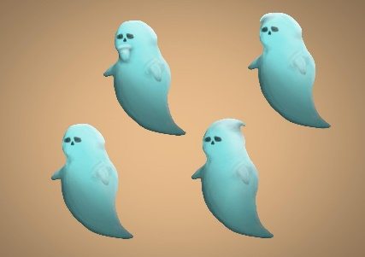The ghosts are central to the game’s art style and have cute and simple designs with their story or functionality acting as darker undertones. They will have three possible variations of head-type and a possibility of having a beard, as it is important that they feel dynamic.

The environment is vibrant and colorful with strange, unknown plant life to explore and discover. The color of the sky and the ambient atmosphere and lighting will change depending on the time of day to represent scorching heat in the day and cold darkness at night. The mountains rise high above the ground with magnificence, and the ruins in the distance give a sense of grandeur and mystery.

## *6.2. Sound*

Musically, the game is mostly silent, but it contains three musical pieces that will be played in different scenarios; when the player has been in a base, has been traveling or has been in a mysterious area for a little while. When the songs are triggered, they will play once to guide and emphasize the player’s feelings before leaving them in silence and solitude again.

When there is no music, the player is left with an ambient soundscape depending on their surroundings, such as wind, sand, water and creatures as well as the sounds of their actions, such as them gathering resources or building platforms or the sound of their machines.

# 7.0. Level Design

The demo only consists of one biome, but we can divide this biome into smaller areas to better plan how it plays out. The level design of the whole biome is split into a beginning, a middle and an end, although the player will travel back and forth between new and old places. The middle is split into four smaller areas. Throughout these areas, the player will be given optional places to explore and shortcuts to unlock, to ensure they can choose their playstyle and play at their own pace. If they wish, they can also spend their time gathering enough resources to skip parts of the game.

## *7.1. The start*

The player starts in an introductory area. Here, they are given what they need to survive for a bit and an introduction to the various systems of the game. The player’s task for the first area is to get acquainted with the systems of the game. But their survivability and possibilities are limited until they move into the next area.

## *7.2. The middle: Area 1*

As the player ventures from the beginning and the game starts for real, they are met with a landscape full of new plant life and more resources. The task for this area is to get familiar with the game’s systems beyond an introduction and build a base of operations. To progress, the player must learn the importance of the building system and build a bridge across the ravine.

## *7.3. The middle: Area 2*

On the other side of the ravine, the plant life is thinner. Here, the player must learn to survive their travels with less readily available resources. To reach the next area, the player must get to the top of the mountains, but they must choose to take a longer route or build a shortcut to a shorter one.

## *7.4. The middle: Area 3*

Atop the mountains, there are almost no resources in the form of food and drink available. The player must learn to not only survive on less resources but prepare well before traveling to this area. Again, the player must build a bridge to progress to the other side of the mountaintops.

## *7.5. The middle: Area 4*

This is the last of the areas in the middle of the game. It contains a long stretch that leads to the end. But before being able to go there, the player must upgrade their abilities and master the survival parameters.

## *7.6. The end*

After traversing the long stretch of the final area of the middle of the game, the player is rewarded with some water and food. They can take their time and slowly move resources and build a base here, or they can prepare well and use it as a small recharge before entering the end. Once the player enters the end, it will not be easy to return, as they must drop down many tall steps. Along the way, they will get some powerful foods as rewards, but they must also be well prepared for the long walk to survive. The corridor leads through the bottom of the ravine in the middle of the map to an underground ruin where the player will find a key to the entrance to Arídea. Going through this ruin, the player will end up above the entrance.

# 8.0. User Interface (UI)

Since many elements of Arídea: The Forgotten Desert relies on or is affected by the UI, it is incorporated into the gameplay, as it appears on a tablet that the player holds in their hand. The UI immerses the player into the world and unifies the design with the gameplay.

Inventory management is a key aspect of the game, so we have gone with an inventory system like the one in Subnautica. It is visually represented as a grid with some items taking up one space, while others take up two or four spaces. Items in the inventory do not stack but need their own space. This will emphasize the management aspect of the inventory as the player won’t always have room for everything, which will increase the investment of the player as they will have to actively make choices.

# 9.0.Technical Requirement

The game is developed for PC with the use of the Unity Engine.